STRENGTHS, WEAKNESSES, OPPORTUNITIES, AND CHALLENGES EVALUATION
On Monday, August 29, 2022, City of Scappoose staff and MIG consultants toured city parks and trails to discuss opportunities to enhance existing and planned parks. City staff prepared the map in Figure 1 to show the location of the sites on the tour and provided a list of facilities for each. Preliminary notes from the park tour are summarized in this Strengths, Weaknesses, Opportunities and Challenges (SWOC) Evaluation. Overarching findings will be discussed with the Scappoose Parks & Recreation Committee (SPRC), who will have an opportunity to add their insights regarding individual parks and citywide observations about the park and recreation system. This information provides an overview of the existing park system to inform the Phase 2 assessment of community park and recreation needs.
The SWOC evaluation includes notes on the following:
- Developed Parks: Heritage Park, Veterans Park, Miller Park, Chief Concomly Park, Creekview Park, Trtek Trailhead/Crown Zellerbach (Crown Z) Trail, Chapman Landing
- Undeveloped Parks: Vista Property, Grabhorn Property, Cat Head Property
- Other Sites and General Opportunities: PUD Substation, South Fork HOA Pocket Park, and General Citywide Observations
Content is summarized by site in the order noted above. All information in this evaluation is based on preliminary observations and shared information that should not be interpreted as recommendations or guidelines. The information includes the notes and “potential opportunities” that will be vetted through public outreach and a technical analysis.

Figure 1: Citywide Map – Park Properties
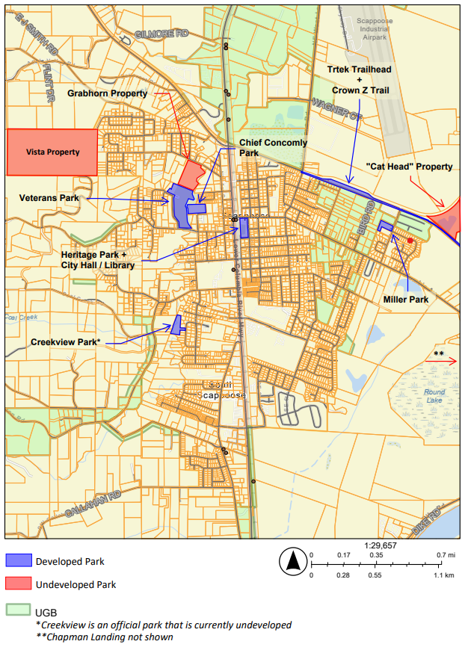

Heritage Park
Classification: Community Park Acres: 1.8
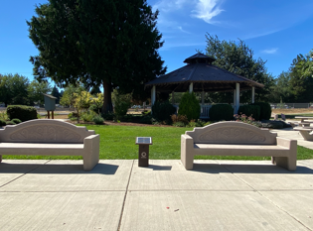
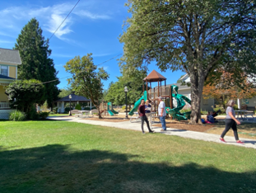
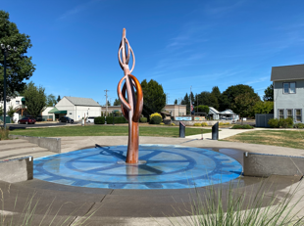
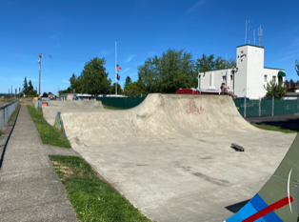

Facilities
- Open turf area/event space
- Playground
- Skate park
- Fountain
- Gazebo
- Picnic tables, tables, and benches
- Restroom
- VFW Memorial
- Electrical hookups
- Off-street parking
- City Hall and Police Lot

Strengths
- A quality civic and community space
- Parking available at City Hall and angle-in street parking
- Adjacent to Library, City Hall, and the Watts House
- Supports large and small gatherings
- Provides varied uses/experiences that attract residents from across the community
- Provides playful experiences for a diversity of age groups
- Clean and well-maintained
- Attractive plaza and seating options outside Library
- Includes unique features that support City identity such as Veterans Memorial, skatepark art, food-share box, historic signage, and iconic fountain
- Takes advantage of enhanced uses through partnerships and intergovernmental agreements (IGAs) with the Historical Society, Library Groups, Veterans of Foreign Wars
- Shared maintenance responsibilities for landscaping around the library and museum garden that add to park character (without municipal costs)
- Includes solar chargers in seating area (funded through grants)
- Includes some attractive shade trees
- Renovated in 2016 through Oregon Parks and Recreation Department (OPRD) grant

Weaknesses
- Site is small for a civic space, community gathering space, and neighborhood park
- Public events are adjacent to the railroad and subject to train noise
- Skate park could have more visibility
- Play structure needs more visibility
- Park’s individual elements feel disconnected and could be more synergistic/triangulated
- Lack of diverse vegetation and trees
- Fountain maintenance

Potential Opportunities
- Reconfigure angle-in parking to incorporate CRPUD and Tesla-sponsored vehicle charging stations (planned)
- Redesign the parking to be more accessible
- Enhance teen amenities or move them elsewhere
- Incorporate pads and utilities for food trucks, ice cream trucks, etc.
- Introduce pop-up games/events and programming
- Enhance plantings within the park
- Add more trees for shade, comfort, and habitat enhancement
- Strengthen connections to City Hall and encourage employees to use the park, eat lunch outside, etc.
- Add a low berm to separate park from railroad track

Challenges
- Site size and location along railroad tracks and Hwy 30 constrain the park’s uses
- Lack of space to expand the teen activity area
- Attractiveness of some landscaped areas is contingent upon quality of non-profit/volunteer efforts
- Money is already invested here so altering amenities may not be desired

Veterans Park
Classification: Community Park Acres: 14 acres
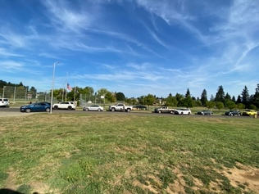
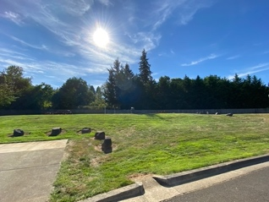
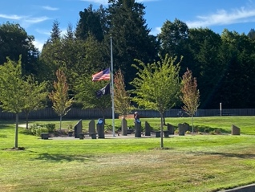
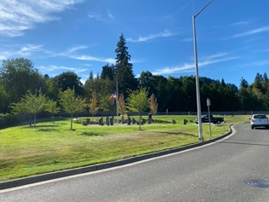

Facilities
- Baseball fields (with dugouts)
- Restroom (dual)
- Concession building
- Picnic shelters
- Playground
- Dog park
- VFW Memorial and Tranquility Zone
- Bocce courts
- On-site parking
- Overflow parking
- Public Works equipment building
- Off-leash dog area
- Lighting

Strengths
- Large, active, developed park (largest in City)
- Memorial to honor and remember all veterans
- Pedestrian and bicycle access
- City’s primary space for large events (e.g., Adventure Festival)
- Variety of spaces for events and smaller, everyday gatherings
- Opportunities for active and passive experiences
- Loop perimeter path
- Opportunities for walking, sitting, picnicking, and watching sports events
- Clean and well-maintained
- ADA accessible
- Successful IGA with Little League to fund various improvements (fencing, dugouts)

Weaknesses
- Captain Roger Kucera Way is functionally a one-way drive when parallel parking occurs along the roadway; parking narrows the travel lanes and creates traffic jams and poor visibility during events
- Overflow parking is not formalized
- Conflicting adjacent uses within the park (bocce ball and memorial)
- Lack of diverse vegetation and trees
- No sidewalk connectivity between Veterans and neighborhoods to the east of Scappoose Creek
- Older; developed 2007 - 2010

Potential Opportunities
- Jointly develop adjacent Grabhorn property for synergies between sites
- Enhance creek visibility, access and crossing to adjacent to Chief Concomly Park
- Explore creating a formal parking lot and prohibiting on-street parking to improve vehicular flow and enhance pedestrian visibility and safety during events
- Land available for off-street parking, limit parking along roadway
- Enhance play opportunities and increase variety of play experiences
- Add disc golf along creek
- Provide more experiences for teens and young adults
- Provide more sports courts (pickleball)
- Enhance trees and plantings within the park
- Provide more seating, more shade, and more comfort opportunities
- Add art or features to highlight City’s identity
- Construct sidewalk on SW JP West Road to connect Veterans to the pedestrian network, providing access to neighborhoods east of Scappoose Creek

Challenges
- Events (and inflatables on grass) damage sports fields
- Maintenance and over-lapping responsibilities (City, Little League)

Miller Park
Classification: Neighborhood Park Acres: 2.0
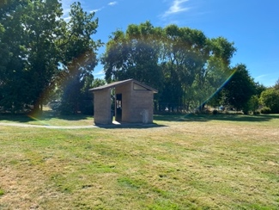
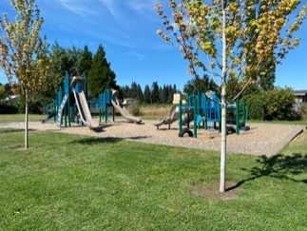
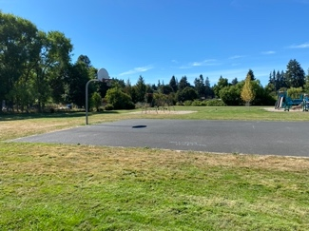

Facilities
- Restroom
- Small picnic shelter
- Playground
- Swing set
- Basketball court
- Little Lending Library
- On-site parking

Strengths
- A quiet park site nestled into a residential neighborhood
- Feels open and spacious yet enclosed and safe
- Bordered by trees on three sides
- A topographically flat site
- Pedestrian and bicycle access
- Little Lending Library at the entrance
- New trees provide some shade
- Clean and well-maintained
- Field serves as storm facility
- Site renovated in 2018-2019
- Dirt/fill added to improve site use (raised playground)

Weaknesses
- No circulation or paths of travel within the park (not accessible)
- Very few trees in the main area of the park
- Very little vegetation aside from open lawn
- Basketball court is close to parking lot
- Swings are not adjacent to other features
- Little variety and no cohesion among the few elements provided
- Features and design are not contextual and unique to Scappoose
- Property is L-shaped, with a back field that is not visible from rest of site
- Limited use of back portion of site
- Limited parking used for nearby trail

Potential Opportunities
- Enhance accessibility
- Enhance variety of amenities
- Enhance basketball court (colorized surfacing) since it is the only full court in the park system
- Install a larger restroom
- Add circulation paths and landing spots between parking and amenities
- Add dog run/walk area (possible larger dog park)
- Add sports court (possible pickleball location)
- Create trike track/walking loop
- Enhance play opportunities and increase variety of play experiences
- Add fitness stations equipment
- Create a connection to the airplanes flying by overhead (e.g., playground theme)
- Enhance trees and plantings within the park
- Provide more seating, more shade, and more comfort opportunities
- Use open field as informal sports field (when dry)
- Explore need for informational signage to Trtek Trailhead parking

Challenges
- Drainage
- Additional fill needed in back rectangle to make usable
- Adjacent to neighbors on three sides
- Mosquitos due to wet ground and standing water after heavy rains
- Insufficient parking. Additional parking would be needed if a more active uses (e.g., dog park, pickleball) added

Chief Concomly Park
Classification: Neighborhood Park Acres: 3.0
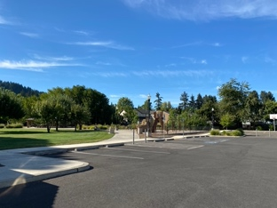
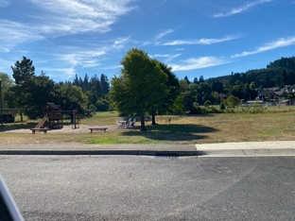
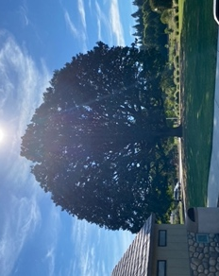
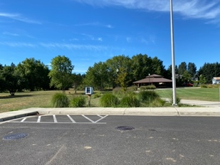

Facilities
- On-site parking
- Pedestrian and bicycle access
- Playground w/ climbing wall
- Gazebo (with electricity)
- Half basketball court
- Restroom (single)
- Drinking fountain
- Benches
- Picnic tables
- Little Lending Library
- Bike rack

Strengths
- Well-designed, quiet park site adjacent to neighborhoods
- Name honors the Chief of the Chinook Tribe at the time of Scappoose’s pioneer settlement
- Adjacent to Grabhorn Property and separated from Veterans Park by a creek
- Large, majestic, historic oak tree
- Apple trees
- ADA accessible
- Clean and well-maintained

Weaknesses
- None

Potential Opportunities
- Enhance play opportunities and increase variety of play experiences
- Provide more experiences for teens and young adults
- Tell the story of the oak and apple trees
- Work to get oak tree on historic register

Challenges
- Lack of sidewalks nearby impedes pedestrian access
- Not dispersed from other parks to serve unserved residential areas

Creekview Park
Classification: Neighborhood Park Acres: 2.7 acres
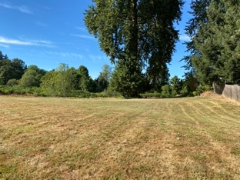
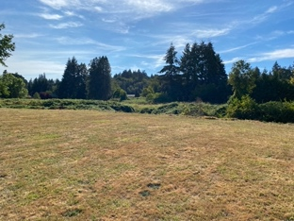
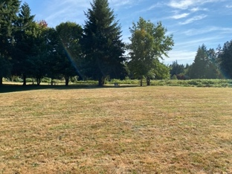

Facilities
- Bench
- Dog waste station
- Open lawn

Strengths
- Open park site along a creek
- Existing trees and open lawn
- Natural character
- Open space for picnicking
- Clean and well-maintained

Weaknesses
- Poor access and visibility (open from vacant lot between two houses)
- No ADA access
- No on-site parking available

Potential Opportunities
- Add nature play features
- Add tricycle track/big wheel loop
- Enhance trees and plantings within the park
- Provide more seating, more shade, and more comfort opportunities
- Provide creek views and access
- Provide additional signage

Challenges
- Shape and limited access are not conducive to extensive use
- Location of nearby neighbors limits ability to add lights or noisy uses (e.g., basketball or pickleball)

Trtek Trailhead/Crown Z Trail
Classification: Linear Park / Trail Acres: trailhead 0.7; trail corridor 2
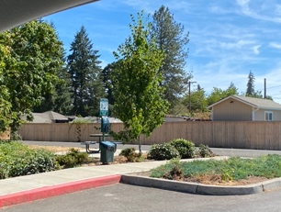
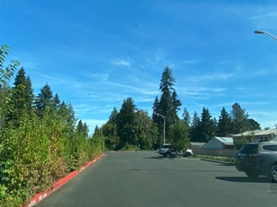

Facilities
- Paved on-site parking
- Drinking fountain
- Bicycle repair station
- Bike rack
- Picnic tables
- Benches
- Restroom (dual)

Strengths
- Bicycle and pedestrian access
- New (built and transferred to City in 2020; amenities partially funded through $15,000 Travel Oregon grant)
- Only paved parking area for trail in Scappoose
- ADA accessible
- Trailhead named after local family (sense of identity)

Weaknesses
- No easy pedestrian access in some locations
- Some sidewalk connections to trailhead (south of trail) are unpaved
- Across road from developer-provided pathway

Potential Opportunities
- Connect to Cat Head Property development
- Provide interpretive signage along trail describing history of the area and natural features
- Add activity stations, parcourse or outdoor fitness equipment along trail
- Add viewpoints and waysides (activity or seating areas)
- Construct sidewalk frontage along West Lane Road (at intersection of new road) to establish connectivity to the west

Challenges
- Coordinate trail with development of light industrial area
- Coordinate trail branding, identity, and signage with County portion of trail

Chapman Landing
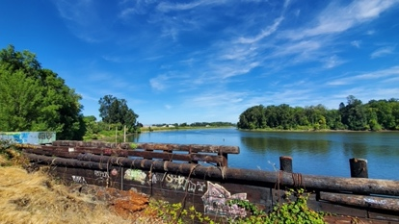
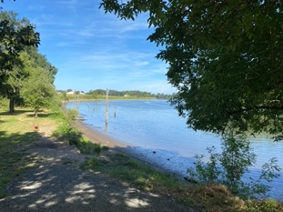
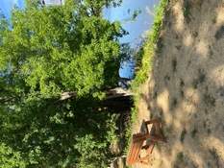
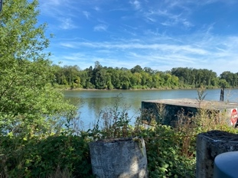
Classification: Special Use Site Acres: 16.0
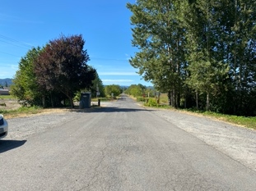

Facilities
- Limited benches and picnic tables
- Pedestrian and bicycle access
- Defacto Parking area
- Portable toilet
- Gate

Strengths
- 2-mile walk to Trtek Trailhead
- Scenic views of Columbia Channel and Sauvie Island
- Viewing opportunities for local wetlands and natural areas
- Water access
- Fishing access
- Historical significance as logging outpost

Weaknesses
- Largely undeveloped
- Limited parking
- Lacks ADA access
- Requires walking on trail from parking lot to the landing
- Invasive plant species
- Dangerous fishing spot on “the pad”
- Located outside of City limits
- Located on City’s sewer outfall
- Requires significant mowing, blackberry invasives management and removal
- Long narrow shape limits access and visibility
- Narrow parking limits parking/turn-around for boat trailers
- Vacant lands may attract homeless campers and nuisance behavior

Potential Opportunities
- Improve as trailhead at endpoint of the Crown Z Trail; explore options for providing amenities such as restroom and bicycle repair station adjacent to parking lot
- Improve parking to maximize spaces
- Provide signage indicating historical context and viewpoints
- Enhance water access points
- Add non-motorized boat ramp (kayak launch)
- Consider boat lockers

Challenges
- Lack of City water and sewer
- Limited on-site parking
- Lack of ADA access
- Sewer outfall eliminates swimming opportunities
- Natural resource work needed
- Extra maintenance required
- Fishing pad liability
- Located on/around the dike complicates development
- Landing is on a dike regulated by USACE
- Desire to activate site with boat-in, bike-in camping may not generate revenues to make this a worthwhile investment

Vista Property
Classification: Undeveloped Park Acres: 71.0 acres
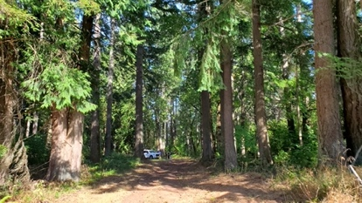
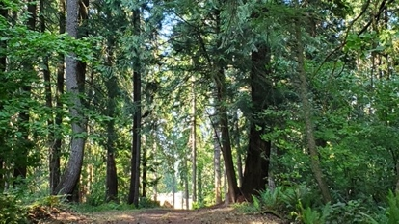
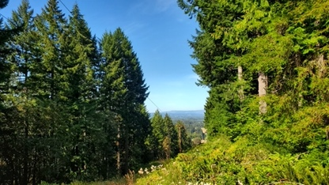

Facilities
- No recreation facilities
- High-zone reservoir (water) tanks (2)

Strengths
- Beautiful, forested hillside site (thinned in 2018)
- Natural area in the City
- Potential views

Weaknesses
- Steep topography (canyon)
- Poor access
- Not currently maintained for park use (landscape/tree maintenance needed)

Potential Opportunities
- Add trailhead with restrooms, bike rack, bike repair station
- Develop with soft surfaced hiking trails
- Implement trails concept plan (developed through NPS grant in 2019)
- Develop with bike skills park and pump track
- Develop with mountain biking trails
- Maintain rustic, natural character and uses
- Open tree canopy for views
- Consider use for fire training/create fire safe environment
- Negotiate to improve access

Challenges
- Limited amount of usable, developable space
- Limited vehicular, pedestrian, and bicycle access
- Adjacent to privately maintained County road
- Adjacent neighboring homes (historically not supportive of park development)
- Invasive species removal and tree maintenance
- Potential for storm damage and wildfires
- Maintenance

Grabhorn Property
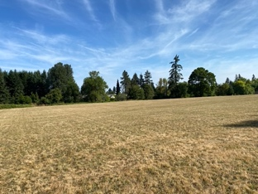
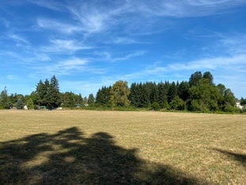
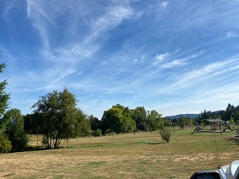
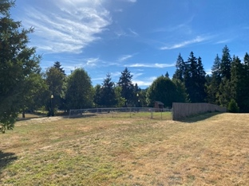
Classification: Undeveloped Park Acres: 9.5 acres

Facilities
- None

Strengths
- Purchased in 2021

Weaknesses
- Sensitive natural areas: any proposed development would require cut-fill balance

Potential Opportunities
- Complete conceptual design (initial concepts currently under review)
- Coordinate development with Veterans Park
- Add sports uses; consider soccer, pickleball and basketball; consider lighted sports courts and fields
- Add challenge opportunities for teens and young adults (enhanced skate park, climbing spire or wall, zip line)
- Open views and access to creek; consider waterfront trail
- Add varied community park uses; consider activity hubs, outdoor fitness equipment (shaded), futsal, bike pump track
- Add shade, trees, and landscaping

Challenges
- Wetland in northwest corner (0.6 acres)
- Located north, and the at end, of Veterans Park (limited opportunities to integrated with existing uses)
- Limited connectivity for accessing the property
- Not well located to support major specialized facilities (e.g., community center)
- Adjacency to Veterans Park does not disperse community park uses around City (i.e., does not enhance access opportunities)

Commerce (“Cat Head”) Property
Classification: Undeveloped Park Acres: 14.1
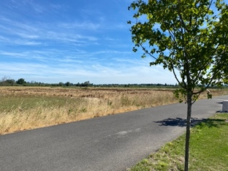
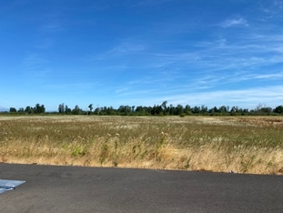
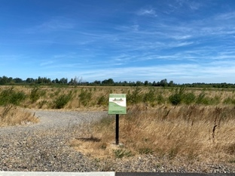

Facilities
- None

Strengths
- Proximity to Trtek Trailhead
- Beautiful, natural site along Crown Z Trail
- Wetlands, pond
- Views
- Transferred to City in 2022 for park use

Weaknesses
- No on-site parking
- Adjacency to light industrial area
- Odd property shape
- Reference name is not well-known/ is not a recognizable community name or feature

Potential Opportunities
- Protect open space/natural areas
- Add nature trail, self-directed nature walks
- Add local/natural art
- Support wildlife viewing
- Provide interpretive signage
- Add nature play elements
- Add par course stations
- Add dog park
- Add picnic opportunities (rustic shelter)
- Add outdoor classroom (learning shelter)
- Coordinate parking opportunity at industrial complex

Challenges
- Wetlands, pond, invasives (blackberries)
- Competing interests (natural area vs. light industrial area)
- Unclear how adjacent agricultural open space will be maintained or developed in future
- Desire for sports fields, which may not be a good fit here

PUD Substation
Classification: None (Other Opportunity) Acres: ~0.42 acres
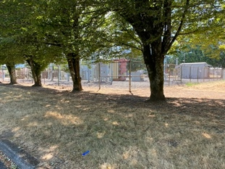
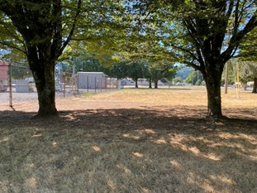
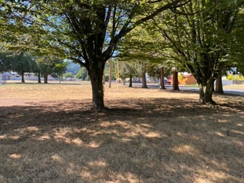

Facilities
- None

Strengths
- Existing trees
- Located in a developed neighborhood, adjacent to E. Columbia Ave and between NE 3rd Street and NE Sawyer Street
- Access from diverse housing types, including multi-family

Weaknesses
- Conflicting uses
- Adjacent to electrical substation

Potential Opportunities
- Use electrical substation as design inspiration for small park and play area

Challenges
- Needs to be rezoned
- Proximity to electrical substation
- Guy wires

South Fork HOA Pocket Park
Classification: None (Other Opportunity) Acres: Unknown

Facilities
- Basketball court
- Tot lot (play equipment for children ages 2-5)

Strengths
- Provides easy access to nearby neighbors

Weaknesses
- Small site has limited uses
- Park does not provide variety of uses like City-owned neighborhood parks

Potential Opportunities
- None noted

Challenges
- None noted

General Citywide Observations

Strengths
- Sites are clean and well maintained
- Many sites have unique characteristics and features
- Several partnerships enhance aesthetics and/or recreation opportunities
- Trail corridor supports recreation and non-motorized transportation, with connections clear to Vernonia

Weaknesses
- Lack of shade
- Lack of diversity in recreation options and experiences
- Lack of challenge opportunities for teens and young adults
- Functional issues at several sites
- Access issues at several sites, including undeveloped park properties
- Many recreation opportunities only available through school facilities (e.g., tennis, running track)
- Lack of interconnected bike and pedestrian system

Potential Opportunities
- Expand uses by developing multiple City-owned park properties
- Continue to coordinate with schools for public use of sports fields, sports courts, and track (at schools and at fields behind District offices where JV softball is played)
- Consider school partnerships to provide synthetic turf fields
- Integrate asset management program to track and replace facilities at end of lifecycles
- Continue to coordinate with Watershed Council on climate resiliency and natural resource protection

Challenges
- Prioritizing investments when multiple improvements are needed
- Event spaces in the City all have constraints
- There are few recreational facilities in the south of the City and no parks in the southeast
- If a specialized facility such as a pool or recreation or community center is desired a new site will be needed, ideally located along a main arterial for access.

